Daniel Chapter Four – Babylonian State Document in Scripture
Nebuchadnezzar’s Tree Dream – God Reveals Himself to an Evil, Pagan Emperor
At the beginning of Nebuchadnezzar’s reign, he took the treasures of the Jerusalem temple and put them in the temples of his gods. As most rulers at that time thought, he had reason to believe that his gods were stronger than the God of Abraham, Isaac and Jacob. By the end of Daniel 4, however, God has shown Nebuchadnezzar which God is the true God, and Who it is that sets up kings and brings them down. When Nebuchadnezzar finally realized this, he wasn't shy about telling people what he had learned. He was a true witness, giving testimony to God's great works. His proclamation also gives us another glimpse into more prophecies of upcoming events.
I. Nebuchadnezzar’s Proclamation – BC 562
Daniel 4:1 Nebuchadnezzar the king, unto all people, nations, and languages, that dwell in all the earth; Peace be multiplied unto you.
Daniel 4:2 I thought it good to shew the signs and wonders that the high God hath wrought toward me.
Daniel 4:3 How great are his signs! and how mighty are his wonders! his kingdom is an everlasting kingdom, and his dominion is from generation to generation.
A. Greeting for a proclamation that will go out through all the empire
1. The testimony of a Gentile king about how God changed his heart
a. Nebuchadnezzar is a good example of a witness
b. A witness is one who relates what he has seen and experienced
2. A statement to glorify God
3. A statement of praise to God
B. Nebuchadnezzar immediately sets the stage
1. God's kingdom is eternal
2. God’s dominion is from generation to generation
II. Nebuchadnezzar Is Troubled
Daniel 4:4 I Nebuchadnezzar was at rest in mine house, and flourishing in my palace:
Daniel 4:5 I saw a dream which made me afraid, and the thoughts upon my bed and the visions of my head troubled me.
Daniel 4:6 Therefore made I a decree to bring in all the wise men of Babylon before me, that they might make known unto me the interpretation of the dream.
Daniel 4:7 Then came in the magicians, the astrologers, the Chaldeans, and the soothsayers: and I told the dream before them; but they did not make known unto me the interpretation thereof.5 I saw a dream which made me afraid, and the thoughts upon my bed and the visions of my head troubled me.
III. Nebuchadnezzar Calls for Daniel
Daniel 4:8 But at the last Daniel came in before me, whose name was Belteshazzar, according to the name of my god, and in whom is the spirit of the holy gods: and before him I told the dream, saying,
Daniel 4:9 O Belteshazzar, master of the magicians, because I know that the spirit of the holy gods is in thee, and no secret troubleth thee, tell me the visions of my dream that I have seen, and the interpretation thereof.
IV. Nebuchadnezzar’s Dream
Daniel 4:10 Thus were the visions of mine head in my bed; I saw, and behold a tree in the midst of the earth, and the height thereof was great.  Daniel 4:11 The tree grew, and was strong, and the height thereof reached unto heaven, and the sight thereof to the end of all the earth:  Daniel 4:12 The leaves thereof were fair, and the fruit thereof much, and in it was meat for all: the beasts of the field had shadow under it, and the fowls of the heaven dwelt in the boughs thereof, and all flesh was fed of it. | 
Daniel 4:13 I saw in the visions of my head upon my bed, and, behold, a watcher and an holy one came down from heaven;  Daniel 4:14 He cried aloud, and said thus, Hew down the tree, and cut off his branches, shake off his leaves, and scatter his fruit: let the beasts get away from under it, and the fowls from his branches: | 
Daniel 4:15 Nevertheless leave the stump of his roots in the earth, even with a band of iron and brass, in the tender grass of the field; and let it be wet with the dew of heaven, and let his portion be with the beasts in the grass of the earth:  Daniel 4:16 Let his heart be changed from man’s, and let a beast’s heart be given unto him; and let seven times pass over him. | 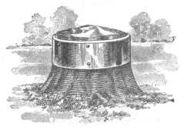

Daniel 4:17 This matter is by the decree of the watchers, and the demand by the word of the holy ones: to the intent that the living may know that the most High ruleth in the kingdom of men, and giveth it to whomsoever he will, and setteth up over it the basest of men.
Daniel 4:18 This dream I king Nebuchadnezzar have seen. Now thou, O Belteshazzar, declare the interpretation thereof, forasmuch as all the wise men of my kingdom are not able to make known unto me the interpretation: but thou art able; for the spirit of the holy gods is in thee.
V. Daniel Is Troubled
Daniel 4:19 Then Daniel, whose name was Belteshazzar, was astonied for one hour, and his thoughts troubled him. The king spake, and said, Belteshazzar, let not the dream, or the interpretation thereof, trouble thee. Belteshazzar answered and said, My lord, the dream be to them that hate thee, and the interpretation thereof to thine enemies.
VI. Daniel Interprets the Dream
Daniel 4:20 The tree that thou sawest, which grew, and was strong, whose height reached unto the heaven, and the sight thereof to all the earth;
Daniel 4:21 Whose leaves were fair, and the fruit thereof much, and in it was meat for all; under which the beasts of the field dwelt, and upon whose branches the fowls of the heaven had their habitation:
Daniel 4:22 It is thou, O king, that art grown and become strong: for thy greatness is grown, and reacheth unto heaven, and thy dominion to the end of the earth.
Daniel 4:23 And whereas the king saw a watcher and an holy one coming down from heaven, and saying, Hew the tree down, and destroy it; yet leave the stump of the roots thereof in the earth, even with a band of iron and brass, in the tender grass of the field; and let it be wet with the dew of heaven, and let his portion be with the beasts of the field, till seven times pass over him;
Daniel 4:24 This is the interpretation, O king, and this is the decree of the most High, which is come upon my lord the king:
Daniel 4:25 That they shall drive thee from men, and thy dwelling shall be with the beasts of the field, and they shall make thee to eat grass as oxen, and they shall wet thee with the dew of heaven, and seven times shall pass over thee, till thou know that the most High ruleth in the kingdom of men, and giveth it to whomsoever he will.
Daniel 4:26 And whereas they commanded to leave the stump of the tree roots; thy kingdom shall be sure unto thee, after that thou shalt have known that the heavens do rule.
Daniel 4:27 Wherefore, O king, let my counsel be acceptable unto thee, and break off thy sins by righteousness, and thine iniquities by shewing mercy to the poor; if it may be a lengthening of thy tranquility.
VII. Nebuchadnezzar’s Dream Fulfilled
Daniel 4:28 All this came upon the king Nebuchadnezzar.
Daniel 4:29 At the end of twelve months he walked in the palace of the kingdom of Babylon.
Daniel 4:30 The king spake, and said, Is not this great Babylon, that I have built for the house of the kingdom by the might of my power, and for the honour of my majesty?
Daniel 4:31 While the word was in the king’s mouth, there fell a voice from heaven, saying, O king Nebuchadnezzar, to thee it is spoken; The kingdom is departed from thee.
Daniel 4:32 And they shall drive thee from men, and thy dwelling shall be with the beasts of the field: they shall make thee to eat grass as oxen, and seven times shall pass over thee, until thou know that the most High ruleth in the kingdom of men, and giveth it to whomsoever he will.
Daniel 4:33 The same hour was the thing fulfilled upon Nebuchadnezzar: and he was driven from men, and did eat grass as oxen, and his body was wet with the dew of heaven, till his hairs were grown like eagles’ feathers, and his nails like birds’ claws.
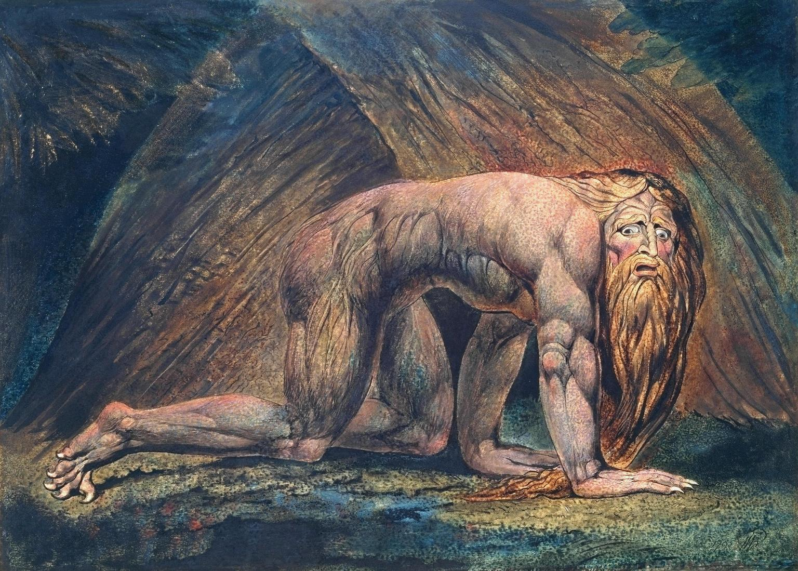
VIII. Nebuchadnezzar’s Kingdom Restored
Daniel 4:34 ¶ And at the end of the days I Nebuchadnezzar lifted up mine eyes unto heaven, and mine understanding returned unto me, and I blessed the most High, and I praised and honored him that liveth for ever, whose dominion is an everlasting dominion, and his kingdom is from generation to generation:
Daniel 4:35 And all the inhabitants of the earth are reputed as nothing: and he doeth according to his will in the army of heaven, and among the inhabitants of the earth: and none can stay his hand, or say unto him, What doest thou?
Daniel 4:36 At the same time my reason returned unto me; and for the glory of my kingdom, mine honour and brightness returned unto me; and my counsellors and my lords sought unto me; and I was established in my kingdom, and excellent majesty was added unto me.
A. At the end of the "7 Years" he lifted up his eyes to Heaven
1. A beast does not do that.
2. An ox, looks downward.
B. Nebuchadnezzar meant that he looked up acknowledging God’s supremacy.
1. In the doing of that his reason was restored
2. and he was fit to resume his kingly duties.
C. Nebuchadnezzar's restoration was fulfillment of the promise
1. His trial lasts seven years, until he realizes God is in control, not himself
2. His Kingdom should then be restored to him.
D. During his judgment, his son, Evil-Merodach, is said to have reigned
E. He lived only about a year after his restoration to his throne
1. Great honors were heaped upon him
2. He glorified God.
F. He died after a brief illness in BC 561
G. He was succeeded by his son Evil-Merodach
IX. Nebuchadnezzar Praises God
Daniel 4: 37 Now I Nebuchadnezzar praise and extol and honour the King of heaven, all whose works are truth, and his ways judgment: and those that walk in pride he is able to abase.
A. A repentant Nebuchadnezzar is restored, and praises God
B. This is knowledgeable testimony "from the horse's mouth"
C. We might learn from this and be spared a hard lesson
X. Observations - Prophetic significance in this story
A. Babylon will play a part in the last part of the Times of the Gentiles
(Isaiah 13-14 and Jeremiah 50-51)
Isaiah 14:3 And it shall come to pass in the day that the LORD shall give thee rest from thy sorrow, and from thy fear, and from the hard bondage wherein thou wast made to serve,
Isaiah 14:4 That thou shalt take up this proverb against the king of Babylon, and say, How hath the oppressor ceased! the golden city ceased!
Isaiah 14:5 The LORD hath broken the staff of the wicked, and the sceptre of the rulers.
Isaiah 14:6 He who smote the people in wrath with a continual stroke, he that ruled the nations in anger, is persecuted, and none hindereth.
Isaiah 14:7 The whole earth is at rest, and is quiet: they break forth into singing.
B. Nebuchadnezzar – A Type of All Gentile Rulers In Times of the Gentiles
1. Nebuchadnezzar's madness foreshadows the madness of Gentile nations
1. Their rejection of God
2. Their pride
2. Nebuchadnezzar’s fall typifies Jesus' judgment of the nations
3. Nebuchadnezzar’s restoration foreshadows the restoring of some of these nations in the millennial kingdom

C. Gentile Nations Judged – Takes Place Following 2nd Coming
1. We Saw It First With Abraham
Genesis 12:3 And I will bless them that bless thee, and curse him that curseth thee: and in thee shall all families of the earth be blessed.
2. Christ Called This Period “The Times of the Gentiles”
Luke 21:24 And they shall fall by the edge of the sword, and shall be led away captive into all nations: and Jerusalem shall be trodden down of the Gentiles, until the times of the Gentiles be fulfilled.
3. Joel States God Will Deliver His People from the Gentiles
Joel 3:1 For, behold, in those days, and in that time, when I shall bring again the captivity of Judah and Jerusalem,
Joel 3:2 I will also gather all nations, and will bring them down into the valley of Jehoshaphat, and will plead with them there for my people and for my heritage Israel, whom they have scattered among the nations, and parted my land.
4. Paul Reveals The Mystery Concerning His People
Romans 11:25 For I would not, brethren, that ye should be ignorant of this mystery, lest ye should be wise in your own conceits; that blindness in part is happened to Israel, until the fulness of the Gentiles be come in.
Romans 11:26 And so all Israel shall be saved: as it is written, There shall come out of Sion the Deliverer, and shall turn away ungodliness from Jacob:
Romans 11:27 For this is my covenant unto them, when I shall take away their sins.
5. Christ Explains the Judgment of the Nations
Matthew 25: 31 When the Son of man shall come in his glory, and all the holy angels with him, then shall he sit upon the throne of his glory:
Matthew 25:32 And before him shall be gathered all nations: and he shall separate them one from another, as a shepherd divideth his sheep from the goats:
Matthew 25:33 And he shall set the sheep on his right hand, but the goats on the left.
Matthew 25:34 Then shall the King say unto them on his right hand, Come, ye blessed of my Father, inherit the kingdom prepared for you from the foundation of the world:
Matthew 25:35 For I was an hungred, and ye gave me meat: I was thirsty, and ye gave me drink: I was a stranger, and ye took me in:
Matthew 25:36 Naked, and ye clothed me: I was sick, and ye visited me: I was in prison, and ye came unto me.
Matthew 25:37 Then shall the righteous answer him, saying, Lord, when saw we thee an hungred, and fed thee? or thirsty, and gave thee drink?
Matthew 25:38 When saw we thee a stranger, and took thee in? or naked, and clothed thee?
Matthew 25:39 Or when saw we thee sick, or in prison, and came unto thee?
Matthew 25:40 And the King shall answer and say unto them, Verily I say unto you, Inasmuch as ye have done it unto one of the least of these my brethren, ye have done it unto me.
Matthew 25:41 Then shall he say also unto them on the left hand, Depart from me, ye cursed, into everlasting fire, prepared for the devil and his angels:
Matthew 25:42 For I was an hungred, and ye gave me no meat: I was thirsty, and ye gave me no drink:
Matthew 25:43 I was a stranger, and ye took me not in: naked, and ye clothed me not: sick, and in prison, and ye visited me not.
Matthew 25:44 Then shall they also answer him, saying, Lord, when saw we thee an hungred, or athirst, or a stranger, or naked, or sick, or in prison, and did not minister unto thee?
Matthew 25:45 Then shall he answer them, saying, Verily I say unto you, Inasmuch as ye did it not to one of the least of these, ye did it not to me.
Matthew 25:46 And these shall go away into everlasting punishment: but the righteous into life eternal.

XI. Application
A. God resists the proud but gives grace to the humble
James 4: 6 …. Wherefore he saith, God resisteth the proud, but giveth grace unto the humble.
B. Fall through pride; and a proud look is # 1 on the list of God's most hated sins
Proverbs 6:16 These six things doth the LORD hate: yea, seven are an abomination unto him:
Proverbs 6:17 A proud look, a lying tongue, and hands that shed innocent blood,
Proverbs 6:18 An heart that deviseth wicked imaginations, feet that be swift in running to mischief,
Proverbs 6:19 A false witness that speaketh lies, and he that soweth discord among brethren

Nebuchadnezzar – Type of All Gentile Rulers During The Times of the Gentiles
Nebuchadnezzar  Judged 7 Years | Antichrist Reigns During 7 Year Tribulation  Daniel 9:27
Nebuchadnezzar’s Judgment | Ruthless Oppression of the Gentile Rule  Daniel 9:27; Revelation 13:4-7
Nebuchadnezzar’s Fall | Judgment of the Nations  Matthew 25:31-33; 25:41-45
Nebuchadnezzar’s Restoration | Some of the Gentile nations to the Millennial Kingdom – Matthew 25:34-40

